DSA - I
Question 1:- https://leetcode.com/problems/two-sum/
Solution: - https://leetcode.com/problems/two-sum/submissions/2007287771/
Screenshot:-
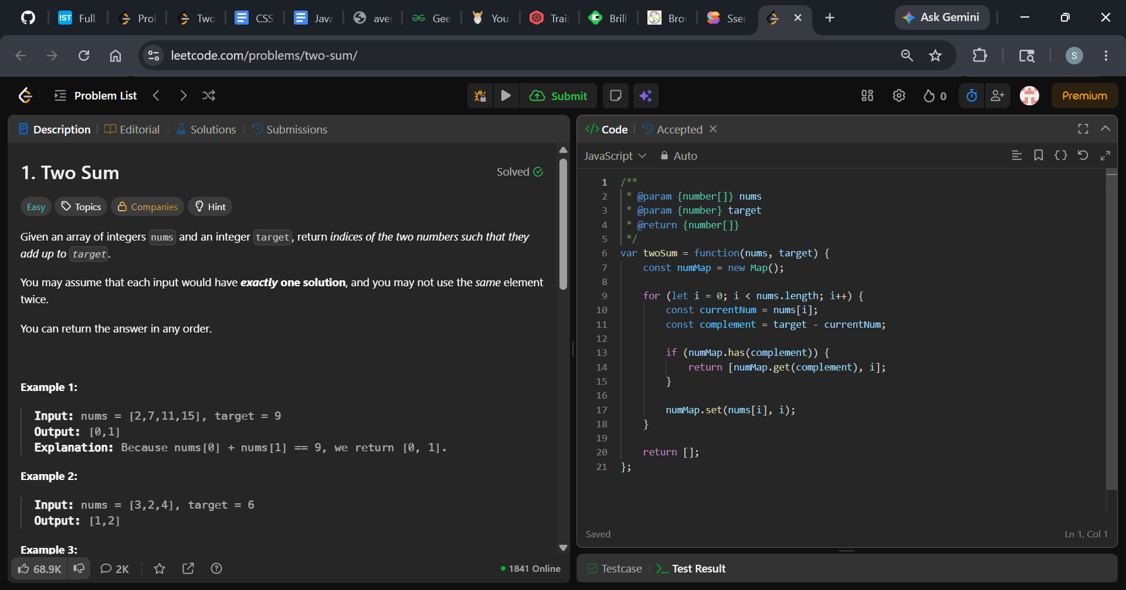
Description: -
- Time Complexity: O(n) — We iterate through the array of length n exactly once.
- Space Complexity: O(n) — In the worst-case scenario, we might store up to n elements in the hash map.

Question 2:- https://leetcode.com/problems/count-number-of-pairs-with-absolute-difference-k/
Solution: - https://leetcode.com/problems/count-number-of-pairs-with-absolute-difference-k/submissions/2008814422/
Screenshot:-
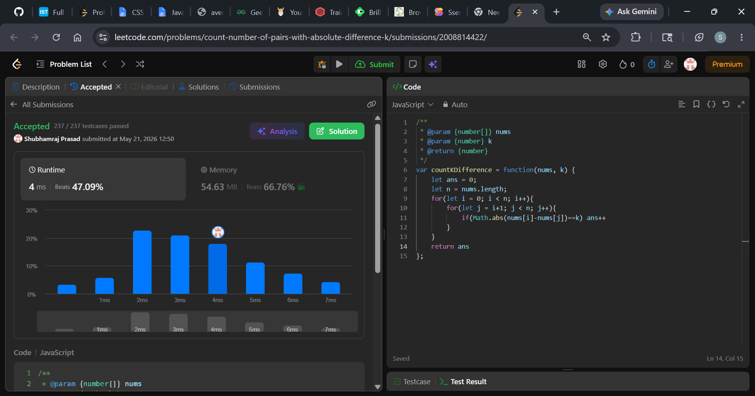
Description: -
- Time Complexity: O(N^2) because of the nested loops. If the array has 1,000 elements, it will execute the inner condition roughly 500,000 times.
- Space Complexity: O(1) constant space, because it only creates a couple of simple variables (ans, n, i, j) regardless of how large the array grows.

Question 3:- https://leetcode.com/problems/number-of-good-pairs/
Solution: - https://leetcode.com/problems/number-of-good-pairs/submissions/2008828996/
Screenshot:-
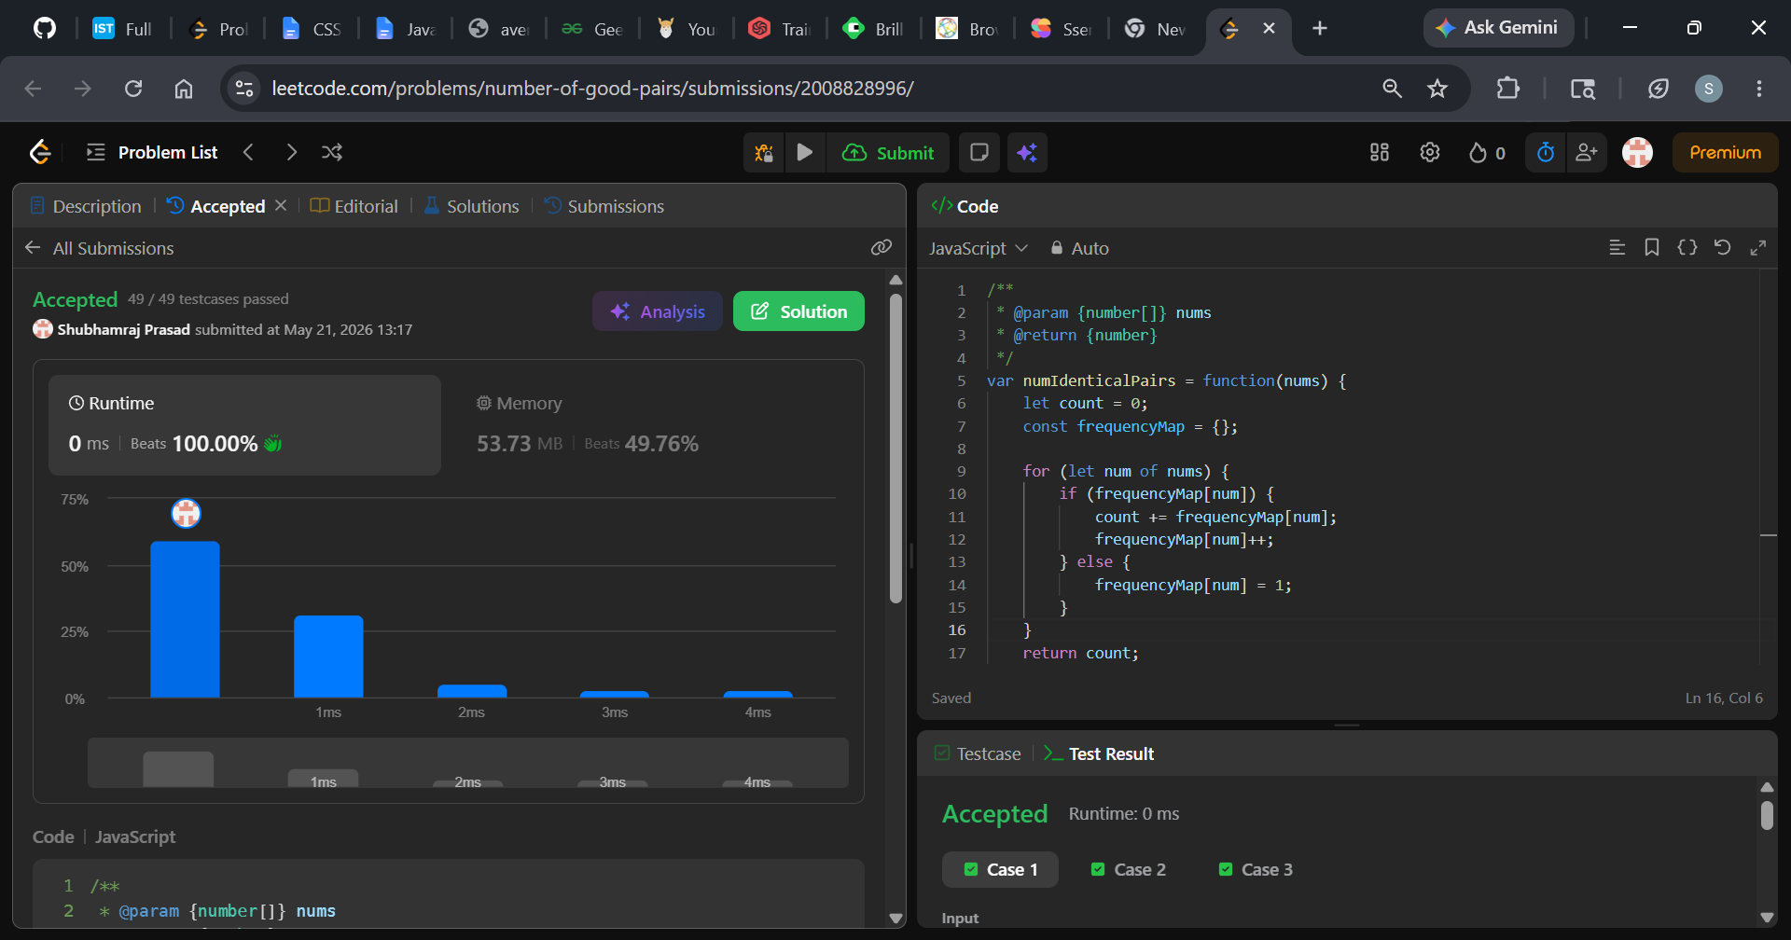
Description: -
- Time Complexity: O(n) The time complexity is linear, where n is the total number of elements in the nums array.
- Single Pass: The code uses a single for...of loop that visits each number in the array exactly once.
- Instant Lookups: Inside the loop, checking if a key exists in an object (if (frequencyMap[num])) and updating it takes O(1) constant time on average.
- Space Complexity: O(n) The space complexity is also linear, where n is the number of elements in the array.
- Memory Allocation: The code creates a new object (frequencyMap) to keep track of the counts.
- Worst-Case Scenario: If every single number in the input array is unique (for example, [1, 2, 3, 4, 5]), the map will grow to store an entry for every single element. Therefore, it will hold n distinct key-value pairs, using O(n) auxiliary memory.

Question 4:- https://leetcode.com/problems/shuffle-the-array/description/
Solution: - https://leetcode.com/problems/shuffle-the-array/submissions/2008903506/
Screenshot:-
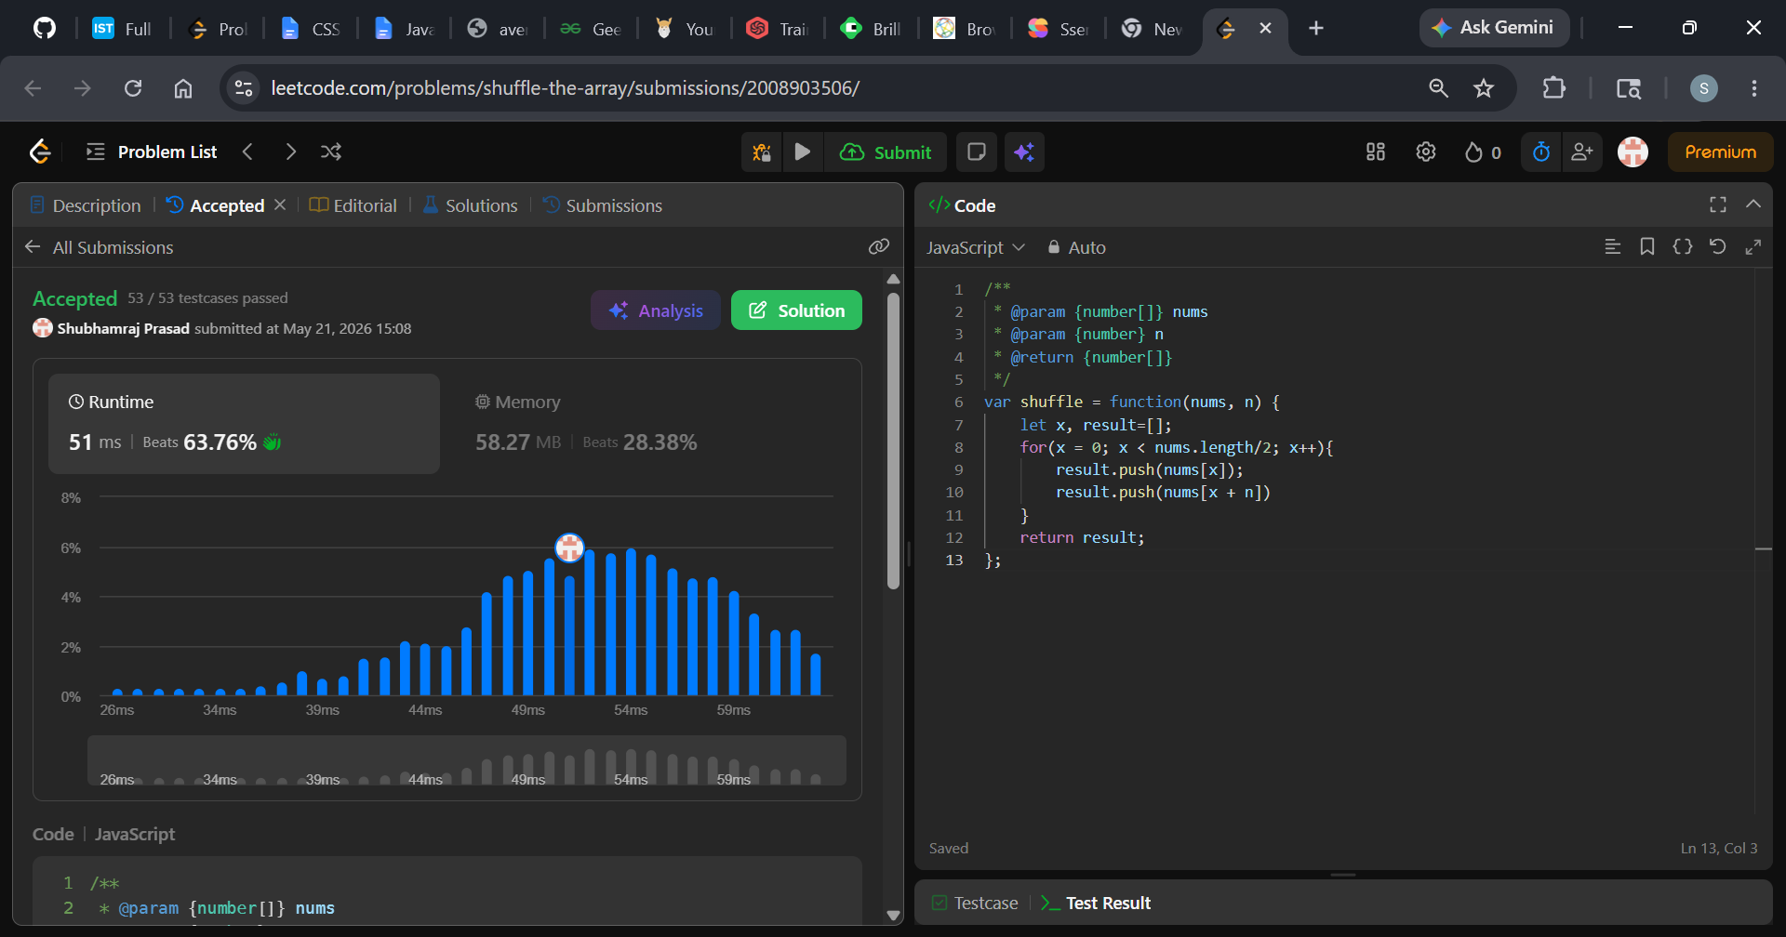
Description: -
- Time Complexity: O(n) — The loop runs exactly n times, making it highly efficient.
- Space Complexity: O(n) — It creates a brand new array (result) that scales linearly with the size of the input.

Question 5:- https://leetcode.com/problems/maximum-subarray/description/
Solution: - https://leetcode.com/problems/maximum-subarray/submissions/2008913138/
Screenshot:-
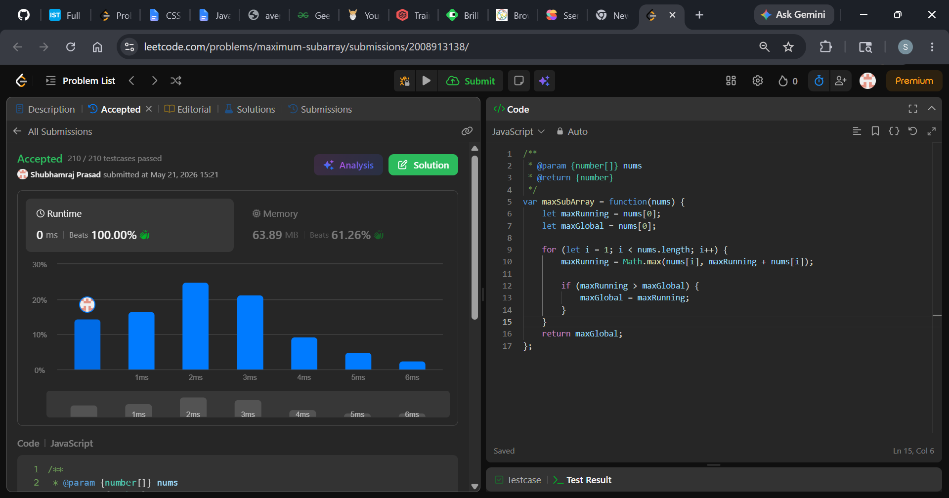
Description: -
- Time Complexity: O(n) - The algorithm uses a single for loop to iterate through the array exactly once. Inside the loop, it only performs constant-time O(1) operations (addition and Math.max). Thus, execution time scales linearly with the input size.
- Space Complexity: O(1) - It only uses two variables (maxRunning and maxGlobal) to track the sums in place. No extra data structures or memory scale with the input size.

Question 6:- https://leetcode.com/problems/binary-search/description/
Solution: - https://leetcode.com/problems/binary-search/submissions/2009137879/
Screenshot:-
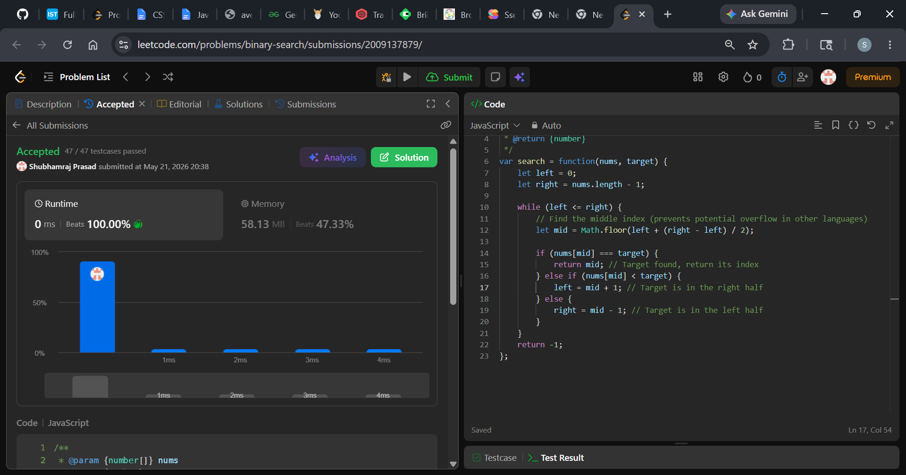
Description: -
- Time Complexity: O(log n) because the search space is cut in half with every single iteration.
- Space Complexity: O(1) as it only uses a few pointers and modifies nothing in memory.

